**What is HTML?**

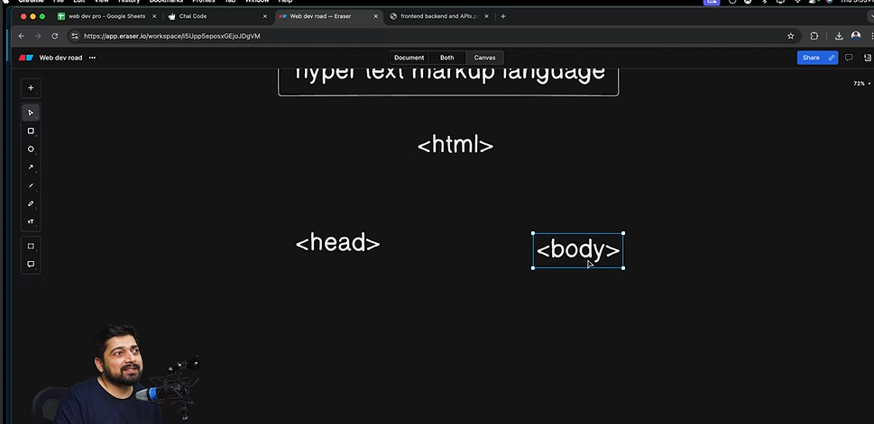

1. HTML stands for “Hyper Text Markup Language”.
2. HTML is divided into 2 parts:
3. Head.
4. Body.
5. Head: This part contains the metadata i.e. information about that particular webpage.
6. Body: This part contains the main content of the webpage.
7. Why the main file in HTML was given the name “index.html”?
8. Servers that are responsible for relaying/sending website data present in the database, are configured to pickup/look-into some of the files automatically, one of those files that will be picked is the fil with the name “index.html”, there are other names which will also be picked automatically.

